1996

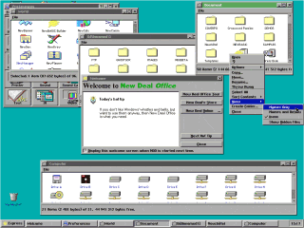 | 1996: New Deal releases New Deal Office 2.5, which was formerly PC-GEOS.
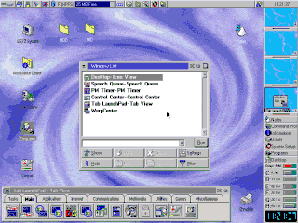 | IBM Releases OS/2 Warp 4 with a significant facelift for the Workplace Shell.
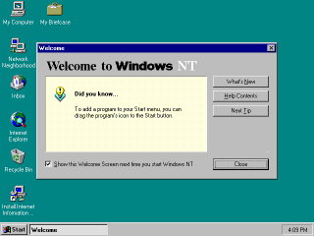 | Microsoft releases Windows NT 4.0 with the same user interface as Windows 95.

1997

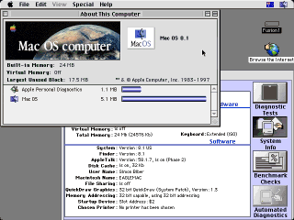 | July 1997: Mac OS 8 is finally released. Selling 1.25 million copies in less than 2 weeks, it becomes the best-selling software in that period.

1998

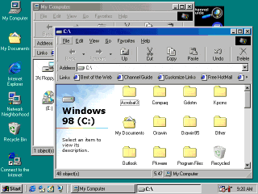 | June 25, 1998: Microsoft releases Windows 98.  Features: Internet Explorer Web browser application takes over the role of the Windows shell, advertising right on the desktop, entire help system replaced by Internet Explorer.
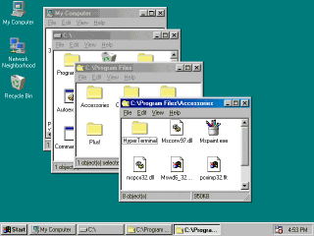 | November 22, 1998: Shane Brooks Releases 98Lite, an installer that removes or prevents the installation of Internet Explorer with Windows 98.  Features No Internet Explorer or advertising, all the hardware support of Windows 98, faster boot time, and the more responsive Windows 95 shell.

1999

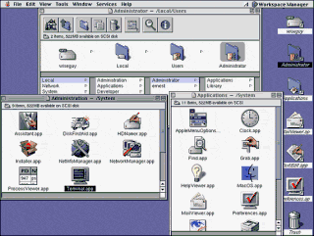 | March 1999 - Apple releases Mac OS X Server, a Unix based OS with their Macintosh GUI.
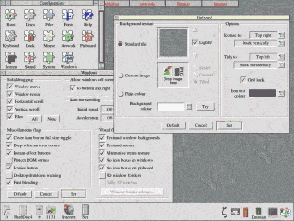 | June 1999 - RISCOS Ltd releases RISC OS 4 for RiscPC, A7000 or A7000+ machines.

2000

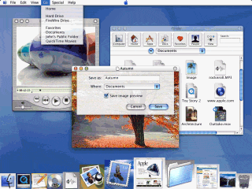 | January 5, 2000: Apple announces Aqua, the new look for their upcoming MacOS X client.
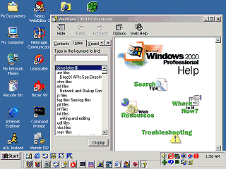 | February 17, 2000: Microsoft Windows 2000 (AKA Windows NT 5) becomes available in stores.  Features: The Internet Explorer web browser application finally takes over the Windows NT UI.

2001

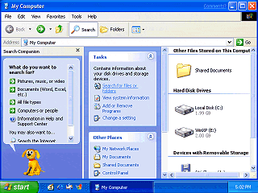 | October 25, 2001: Microsoft releases Windows XP (AKA Windows NT 5.1)  Features:  Tons of eye candy.  "Product Activation" tethers XP to the existence of the Microsoft corporation.

2003

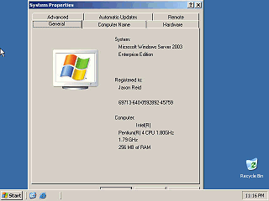 | April 24, 2003: Microsoft releases Windows Server 2003 (AKA Windows NT 5.2 and for a time called "Windows.NET server")  Features:  Drops the eye candy.  Server-only release.

Notes:
I am limiting this timeline to systems that provide GUI services to other applications, this is why I am not including individual graphical DOS apps or older graphical programs such as Sketchpad .
I am also not listing each version of a GUI system unless a significant change has occurred in it. MacOS has kept the same basic user interface since Version 1 and is therefore only mentioned a couple of times. Microsoft, on the other hand thinks it is fun to make users learn a completely new interface every few years, so each of the Windows interfaces is listed. (Except for Windows ME which looked just like Windows 98 and 2000).
Issues:
X could just about have it's own history page. There is no way I can list all of the different appearances of X here so I am just mentioning it's creation. The picture is much more recent and not of the original X.
The picture of NextStep is of a later version.
The picture of PC-Geos is from Geos Ensemble 2.X with the presentation manager look.
The picture of BeOS is from a later version.
The color Mac screen shot is of MacOS 7.5.5, although these machines shipped with earlier versions.
I have insufficient information about the history of Tandy Deskmate and the Apollo workstation to place them on this timeline.

